**PREDIKSI CURAH HUJAN TAHUNAN KABUPATEN KENDAL**

1. **Data Tabel Aktual**

|  |  |  |  |  |  |  |  |
| --- | --- | --- | --- | --- | --- | --- | --- |
| **Bulan dan Jumlah** | **Kendal** | **Weleri** | **Kaliwungu** | **Boja** | **Sukorejo** | **Rata-rata** | **Tahun** |
| Januari | 621 | 568 | 487 | 526 | 454 | 531 | 2013 |
| Februari | 254 | 357 | 172 | 428 | 486 | 339 | 2013 |
| Maret | 100 | 106 | 50 | 633 | 512 | 280 | 2013 |
| April | 138 | 109 | 142 | 663 | 358 | 282 | 2013 |
| Mei | 85 | 163 | 84 | 208 | 252 | 158 | 2013 |
| Juni | 247 | 246 | 247 | 465 | 202 | 281 | 2013 |
| Juli | 71 | 127 | 121 | 160 | 328 | 161 | 2013 |
| Agustus | 14 | 30 | 55 | 65 | 14 | 33 | 2013 |
| September | 40 | 19 | 0 | 53 | 40 | 22 | 2013 |
| Oktober | 95 | 28 | 88 | 214 | 110 | 107 | 2013 |
| November | 181 | 138 | 105 | 312 | 202 | 188 | 2013 |
| Desember | 301 | 294 | 230 | 377 | 406 | 322 | 2013 |
| **Total** | **2107** | **2185** | **1781** | **4104** | **3350** | **225** | **2013** |
| Januari | 1109 | 824 | 864 | 646 | 947 | 878 | 2014 |
| Februari | 354 | 509 | 344 | 323 | 578 | 422 | 2014 |
| Maret | 149 | 99 | 118 | 409 | 409 | 237 | 2014 |
| April | 62 | 41 | 32 | 448 | 241 | 165 | 2014 |
| Mei | 95 | 149 | 64 | 107 | 184 | 120 | 2014 |
| Juni | 145 | 102 | 136 | 214 | 43 | 128 | 2014 |
| Juli | 55 | 274 | 144 | 205 | 227 | 181 | 2014 |
| Agustus | 89 | 56 | 24 | 97 | 89 | 53 | 2014 |
| September | 3 | 0 | 45 | 0 | 3 | 10 | 2014 |
| Oktober | 39 | 19 | 51 | 82 | 15 | 41 | 2014 |
| November | 191 | 99 | 93 | 314 | 223 | 184 | 2014 |
| Desember | 182 | 200 | 145 | 289 | 410 | 245 | 2014 |
| **Total** | **2381** | **2372** | **2060** | **3134** | **3369** | **222** | **2014** |
| Januari | 429 | 463 | 232 | 505 | 340 | 394.0 | 2015 |
| Februari | 232 | 317 | 176 | 580 | 335 | 328.0 | 2015 |
| Maret | 192 | 177 | 196 | 379 | 265 | 242.0 | 2015 |
| April | 187 | 115 | 94 | 383 | 464 | 249.0 | 2015 |
| Mei | 100 | 74 | 77 | 183 | 153 | 117.0 | 2015 |
| Juni | 68 | 27 | 55 | 5 | 3 | 32.0 | 2015 |
| Juli | 41 | 3 | 31 | 3 | 41 | 15.0 | 2015 |
| Agustus | 0 | 18 | 0 | 18 | 0 | 4.0 | 2015 |
| September | 2 | 0 | 0 | 0 | 2 | 0.4 | 2015 |
| Oktober | 0 | 25 | 8 | 25 | 0 | 7.0 | 2015 |
| November | 121 | 191 | 85 | 201 | 206 | 161.0 | 2015 |
| Desember | 236 | 182 | 252 | 300 | 191 | 232.0 | 2015 |
| **Total** | **1606** | **1564** | **1206** | **2564** | **1959** | **148.0** | **2015** |
| Januari | 183 | 234 | 217 | 296 | 451 | 276 | 2016 |
| Februari | 343 | 312 | 215 | 599 | 538 | 401 | 2016 |
| Maret | 153 | 103 | 87 | 397 | 225 | 193 | 2016 |
| April | 239 | 134 | 177 | 384 | 561 | 299 | 2016 |
| Mei | 171 | 240 | 202 | 321 | 311 | 249 | 2016 |
| Juni | 266 | 228 | 192 | 326 | 288 | 260 | 2016 |
| Juli | 177 | 324 | 210 | 322 | 283 | 263 | 2016 |
| Agustus | 78 | 122 | 93 | 123 | 35 | 90 | 2016 |
| September | 387 | 264 | 278 | 410 | 257 | 319 | 2016 |
| Oktober | 230 | 147 | 160 | 315 | 429 | 256 | 2016 |
| November | 231 | 327 | 223 | 356 | 380 | 303 | 2016 |
| Desember | 188 | 184 | 172 | 510 | 370 | 285 | 2016 |
| **Total** | **2646** | **2619** | **2226** | **4359** | **4128** | **266** | **2016** |
| Januari | 289 | 334 | 308 | 447 | 494 | 374 | 2017 |
| Februari | 391 | 399 | 398 | 350 | 524 | 412 | 2017 |
| Maret | 168 | 98 | 120 | 474 | 317 | 235 | 2017 |
| April | 91 | 55 | 90 | 490 | 187 | 183 | 2017 |
| Mei | 29 | 139 | 44 | 294 | 266 | 154 | 2017 |
| Juni | 158 | 136 | 172 | 225 | 212 | 181 | 2017 |
| Juli | 65 | 103 | 66 | 57 | 27 | 64 | 2017 |
| Agustus | 5 | - | - | - | - | 1 | 2017 |
| September | 21 | 45 | 39 | 64 | 87 | 51 | 2017 |
| Oktober | 177 | 111 | 316 | 336 | 225 | 233 | 2017 |
| November | 257 | 161 | 297 | 736 | 640 | 418 | 2017 |
| Desember | 242 | 350 | 162 | 413 | 349 | 303 | 2017 |
| **Total** | **1893** | **1931** | **2012** | **3886** | **3328** | **217** | **2017** |
| Januari | 296 | 254 | 288 | 474 | 457 | 354 | 2018 |
| Februari | 604 | 472 | 631 | 726 | 656 | 618 | 2018 |
| Maret | 160 | 213 | 175 | 340 | 354 | 248 | 2018 |
| April | 106 | 230 | 162 | 233 | 294 | 205 | 2018 |
| Mei | 59 | 70 | 40 | 114 | 75 | 72 | 2018 |
| Juni | 34 | 20 | 59 | 110 | 122 | 69 | 2018 |
| Juli | - | - | - | - | - | - | 2018 |
| Agustus | - | - | - | - | 95 | 19 | 2018 |
| September | - | - | - | 70 | - | 14 | 2018 |
| Oktober | 7 | 22 | 12 | - | 34 | 19 | 2018 |
| November | 62 | 115 | 104 | 339 | 195 | 163 | 2018 |
| Desember | 146 | 251 | 160 | 450 | 386 | 279 | 2018 |
| **Total** | **1474** | **1647** | **1631** | **2856** | **2668** | **187** | **2018** |
| Januari | 265 | 414 | 359 | 438 | 390 | 373 | 2019 |
| Februari | 214 | 228 | 203 | 475 | 479 | 320 | 2019 |
| Maret | 233 | 240 | 181 | 524 | 507 | 337 | 2019 |
| April | 235 | 166 | 239 | 574 | 461 | 335 | 2019 |
| Mei | 82 | 161 | 149 | 294 | 324 | 202 | 2019 |
| Juni | - | - | - | - | - | - | 2019 |
| Juli | 5 | 37 | 7 | 4 | 34 | 17 | 2019 |
| Agustus | - | - | 3 | 25 | - | 6 | 2019 |
| September | - | 4 | - | 5 | 1 | 2 | 2019 |
| Oktober | - | - | 19 | 4 | 10 | 7 | 2019 |
| November | 10 | 15 | 50 | 157 | 133 | 73 | 2019 |
| Desember | 143 | 144 | 252 | 295 | 251 | 217 | 2019 |
| **Total** | **1187** | **1409** | **1462** | **2795** | **2590** | **172** | **2019** |
| Januari | 345 | 539 | 375 | 360 | 473 | 418 | 2020 |
| Februari | 353 | 330 | 260 | 606 | 566 | 423 | 2020 |
| Maret | 256 | 258 | 210 | 474 | 532 | 346 | 2020 |
| April | 149 | 93 | 183 | 513 | 254 | 238 | 2020 |
| Mei | 233 | 178 | 243 | 330 | 339 | 265 | 2020 |
| Juni | - | - | - | - | - | - | 2020 |
| Juli | 80 | 121 | 59 | 77 | 113 | 90 | 2020 |
| Agustus | 53 | 38 | 44 | 46 | 127 | 62 | 2020 |
| September | 135 | 50 | 100 | 100 | 143 | 106 | 2020 |
| Oktober | 134 | 65 | 122 | 460 | 186 | 193 | 2020 |
| November | 206 | 282 | 185 | 543 | 469 | 337 | 2020 |
| Desember | 337 | 155 | 298 | 499 | 802 | 418 | 2020 |
| **Total** | **2281** | **2109** | **2079** | **4008** | **4004** | **263** | **2020** |
| Januari | 209 | 384 | 290 | 943 | 813 | 528 | 2021 |
| Februari | 514 | 715 | 727 | 449 | 639 | 609 | 2021 |
| Maret | 151 | 242 | 153 | 363 | 312 | 244 | 2021 |
| April | 65 | 105 | 60 | 171 | 183 | 117 | 2021 |
| Mei | 174 | 111 | 253 | 312 | 251 | 220 | 2021 |
| Juni | 100 | 95 | 237 | 511 | 271 | 243 | 2021 |
| Juli | 18 | 5 | 22 | 23 | 4 | 14 | 2021 |
| Agustus | 13 | 38 | 19 | 190 | 78 | 68 | 2021 |
| September | 92 | 215 | 64 | 205 | 174 | 150 | 2021 |
| Oktober | 28 | 15 | 16 | 121 | 241 | 84 | 2021 |
| November | 279 | 325 | 217 | 462 | 278 | 312 | 2021 |
| Desember | 93 | 167 | 71 | 515 | 935 | 356 | 2021 |
| **Total** | **1736** | **2417** | **2129** | **4265** | **4179** | **245** | **2021** |
| Januari | 186 | 260 | 267 | 278 | 326 | 263 | 2022 |
| Februari | 298 | 323 | 204 | 494 | 443 | 352 | 2022 |
| Maret | 79 | 192 | 101 | 209 | 278 | 172 | 2022 |
| April | 138 | 188 | 101 | 183 | 199 | 162 | 2022 |
| Mei | 120 | 271 | 116 | 342 | 326 | 235 | 2022 |
| Juni | 150 | 147 | 114 | 216 | 253 | 176 | 2022 |
| Juli | 36 | 88 | 48 | 90 | 49 | 62 | 2022 |
| Agustus | 11 | 30 | 20 | 38 | 196 | 59 | 2022 |
| September | 169 | 178 | 135 | 298 | 111 | 178 | 2022 |
| Oktober | 164 | 393 | 141 | 551 | 517 | 353 | 2022 |
| November | 228 | 185 | 247 | 419 | 440 | 304 | 2022 |
| Desember | 323 | 368 | 205 | 449 | 621 | 393 | 2022 |
| **Total** | **1902** | **2623** | **1699** | **3567** | **3759** | **226** | **2022** |
| Januari | 254 | 217 | 284 | 510 | 383 | 330 | 2023 |
| Februari | 275 | 333 | 377 | 327 | 500 | 362 | 2023 |
| Maret | 191 | 201 | 135 | 320 | 223 | 214 | 2023 |
| April | 58 | 77 | 69 | 383 | 301 | 178 | 2023 |
| Mei | 132 | 65 | 80 | 192 | 129 | 120 | 2023 |
| Juni | 73 | 32 | 38 | 23 | 54 | 44 | 2023 |
| Juli | - | 6 | 10 | 55 | 56 | 25 | 2023 |
| Agustus | - | - | - | - | - | - | 2023 |
| September | - | - | - | - | - | - | 2023 |
| Oktober | 35 | 10 | 38 | 23 | 17 | 25 | 2023 |
| November | 124 | 16 | 207 | 265 | 149 | 152 | 2023 |
| Desember | 98 | 125 | 249 | 524 | 322 | 264 | 2023 |
| **Total** | **1240** | **1082** | **1487** | **2622** | **2134** | **143** | **2023** |
| Januari | 241 | 139 | 133 | 336 | 464 | 263 | 2024 |
| Februari | 87 | 185 | 82 | 532 | 503 | 278 | 2024 |
| Maret | 314 | 366 | 183 | 455 | 548 | 373 | 2024 |
| April | 313 | 214 | 188 | 327 | 449 | 298 | 2024 |
| Mei | 27 | 50 | 35 | 200 | 156 | 94 | 2024 |
| Juni | 102 | 56 | 42 | 104 | 134 | 88 | 2024 |
| Juli | 32 | 33 | 4 | 35 | 50 | 31 | 2024 |
| Agustus | 28 | 3 | 8 | 42 | 13 | 19 | 2024 |
| September | 27 | 74 | 30 | 178 | 190 | 100 | 2024 |
| Oktober | 18 | - | 32 | 60 | 65 | 35 | 2024 |
| November | 205 | 241 | 116 | 477 | 621 | 332 | 2024 |
| Desember | 286 | 331 | 129 | 287 | 388 | 284 | 2024 |
| **Total** | **1680** | **1692** | **982** | **3033** | **3581** | **183** | **2024** |

1. **Grafik Pelatihan Model Sarima**
2. **Grafik PACF & ACF**
3. **Kota Kendal**

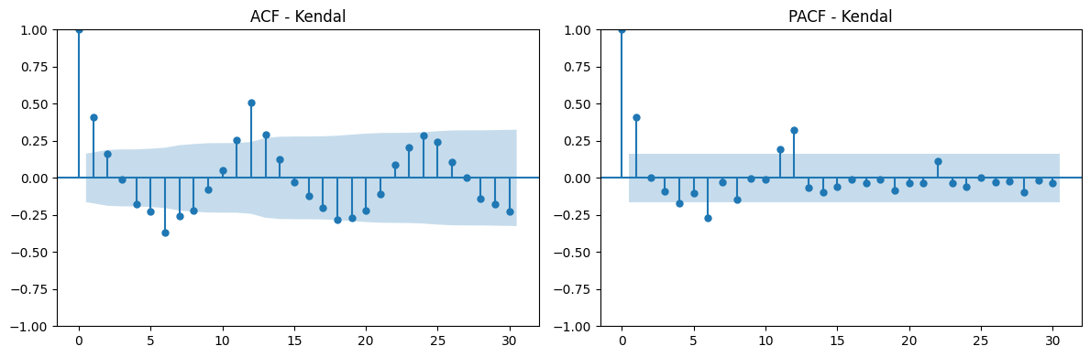

1. **Kota Weleri**

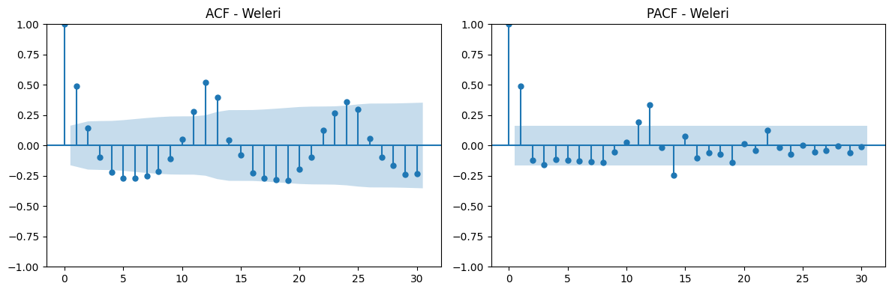

1. **Kota Kaliwungu**

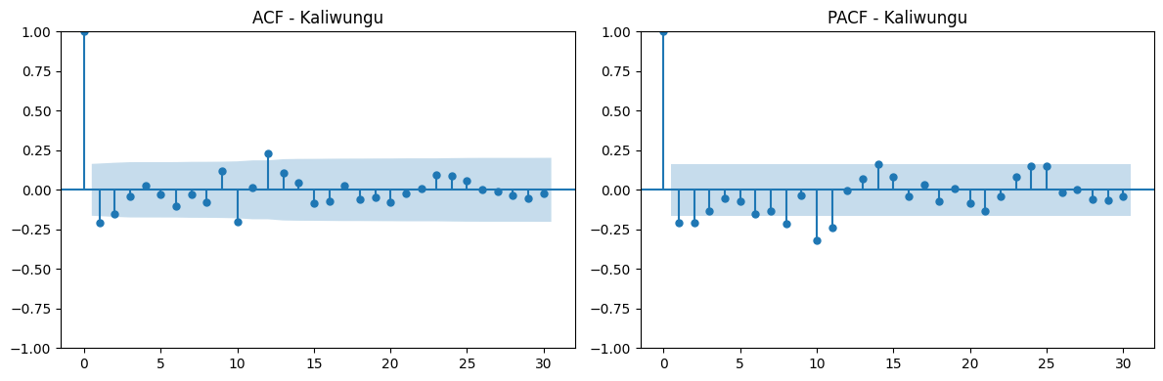

1. **Kota Boja**

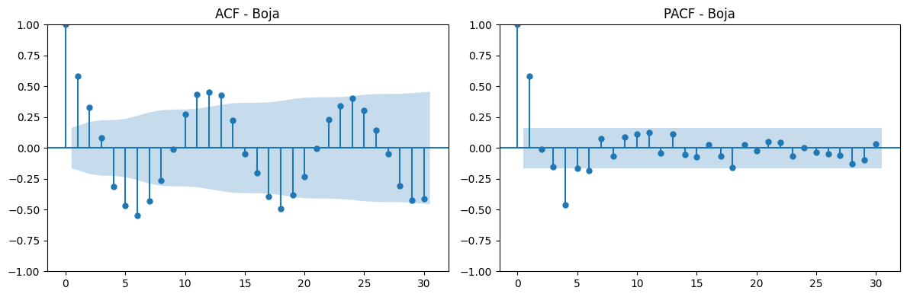

1. **Kota Sukorejo**

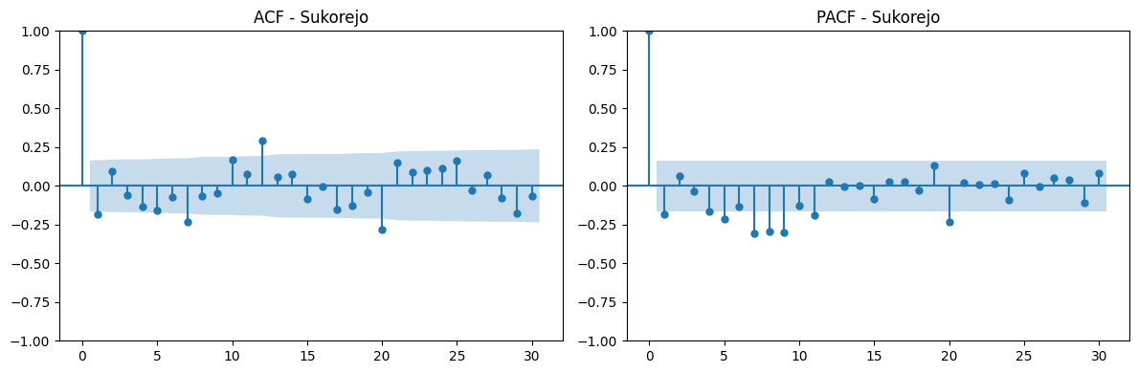

**Insight :** Grafik ACF menunjukkan seberapa kuat korelasi antara data saat ini dengan lag pada berbagai periode sebelumnya, sedangkan PACF digunakan untuk melihat korelasi langsung antara data saat ini dengan lag tertentu setelah pengaruh lag lainnya dihilangkan. ACF berguna untuk mengidentifikasi nilai q pada bagian MA, sedangkan PACF digunakan untuk melihat nilai p pada bagian AR. Dari garifk ACF dan PACF per-kota diatas, dapat ditentukan bahwa nilai parameter (p, d, q, dan s) diperoleh :

* Kota Kendal = (1, 0, 1, 12)
* Kota Weleri = (1, 0, 1, 12)
* Kota Kaliwungu = (1, 1, 1, 12)
* Kota Boja = (1, 0, 1, 12)
* Kota Sukorejo = (1, 1, 1, 12)

**Catatan :** Nilai d diperoleh dari hasil berapa kali Differencing

1. **Grafik Seasonal Decomposition of Time Series**
2. **Kota Kendal**

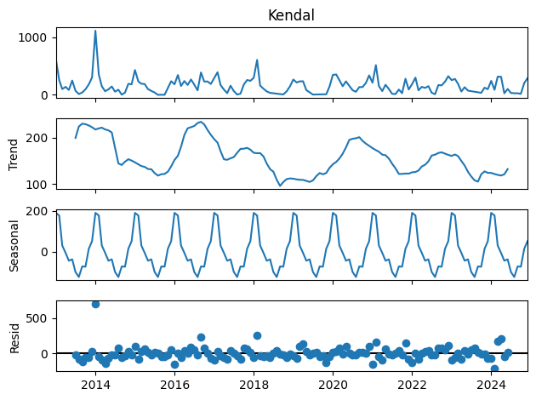

1. **Kota Weleri**

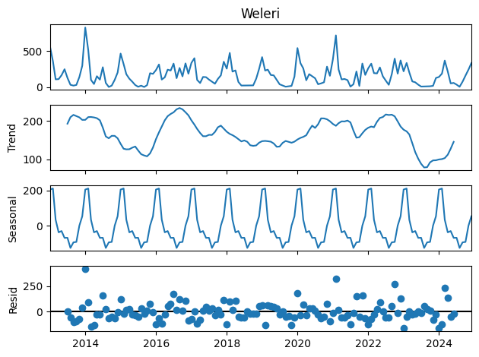

1. **Kota Kaliwungu**

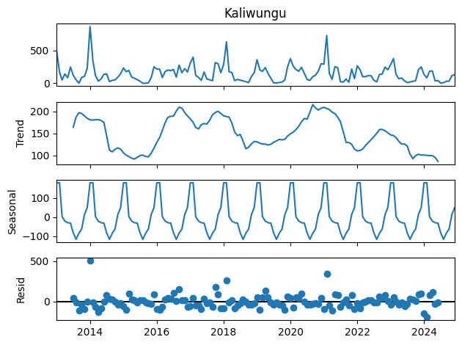

1. **Kota Boja**

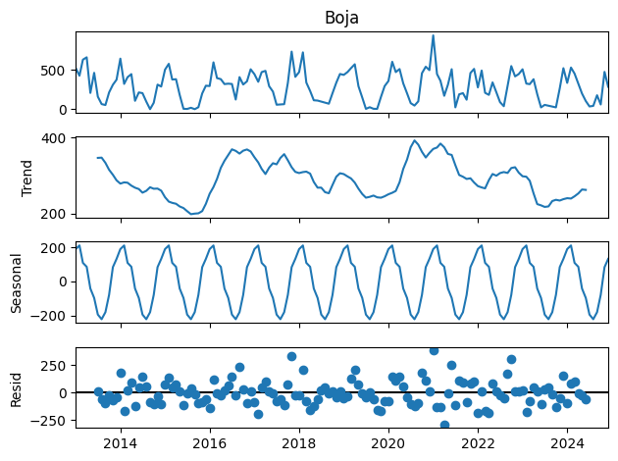

1. **Kota Sukorejo**

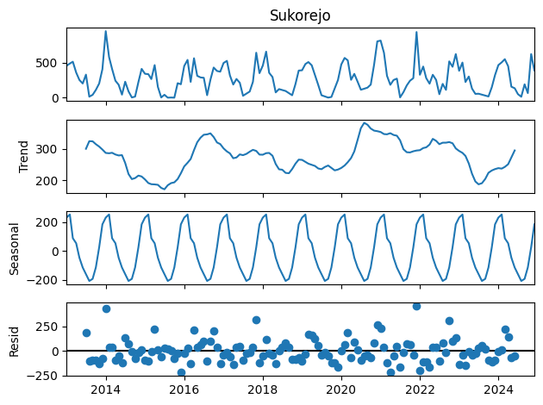

**Insight :** Grafik Seasonal Decomposition of Time Series, digunakan untuk melihat dan menentukan apakah suatu data memiliki pola musiman atau tidak. Melalui dekomposisi ini, data deret waktu dipisahkan ke dalam beberapa komponen yaitu data asli, trend, seasonal, dan resid. Berdasarkan hasil dari grafik Tren per-kota kabupaten Kendal menunjukan pola yang naik turun, artinya terdapat pola jangka panjang. Berdasarkan beberapa grafik diatas dapat disimpulkan bahwa data ini memiliki pola musiman.

1. **Grafik Hasil Prediksi**
2. **Kota Kendal**

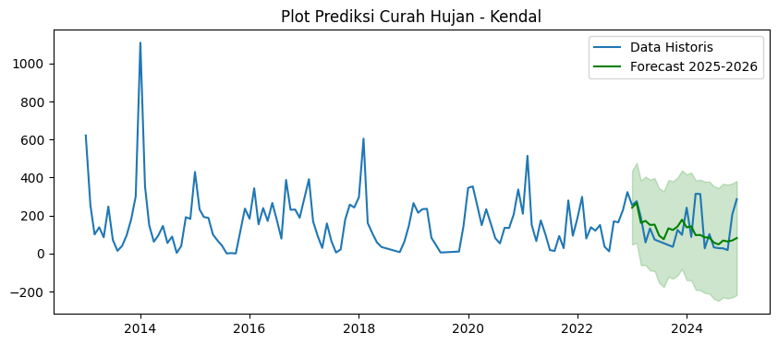

**Insight :** Pola curah hujan 2025–2026 tetap mengikuti tren musiman, tetapi intensitas hujan lebih rendah dibanding data historis. Puncak hujan hanya sekitar 200–300 mm per bulan.

1. **Kota Weleri**

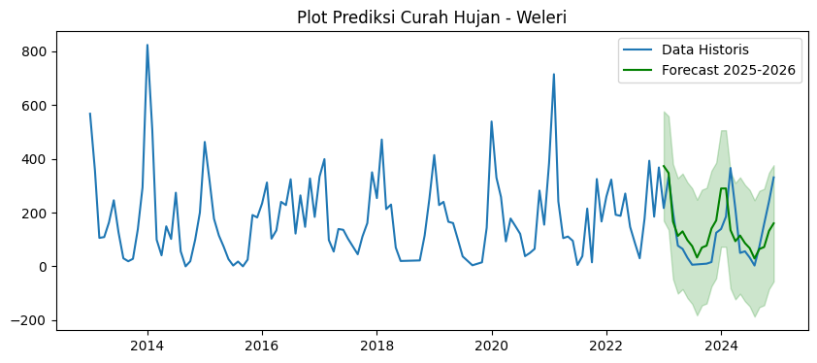

**Insight :** Fluktuasi musiman masih ada, namun amplitudo prediksi lebih stabil dibanding tahun-tahun sebelumnya. Hujan ekstrem di atas 600 mm pada historis tidak lagi muncul di prediksi.

1. **Kota Kaliwungu**

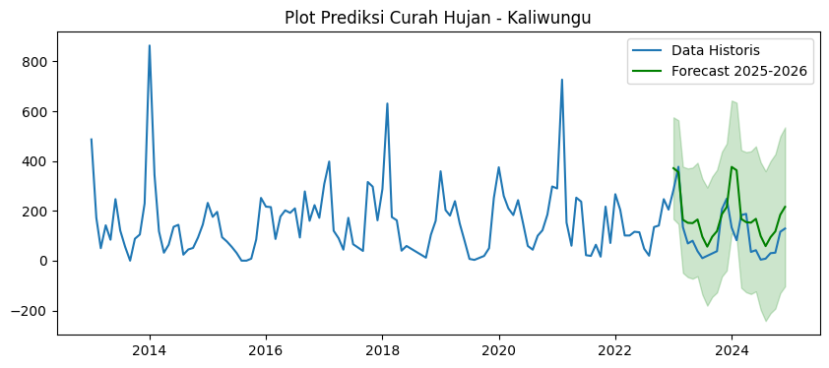

**Insight :** Terlihat pola naik–turun yang jelas, dengan tren menurun pada puncak curah hujan. Intensitas tertinggi berada di kisaran 200–300 mm.

1. **Kota Boja**

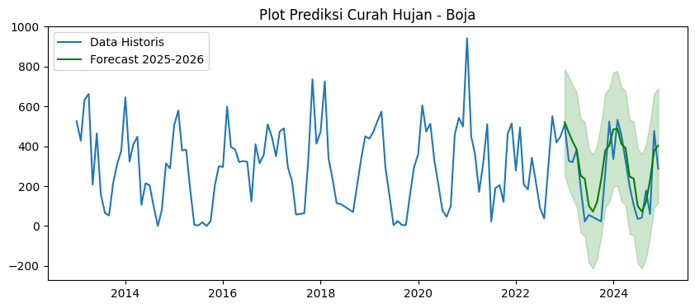

**Insight :** Prediksi menunjukkan pola musiman konsisten, tetapi curah hujan tidak setinggi data historis. Variasi antar bulan lebih landai.

1. **Kota Sukorejo**

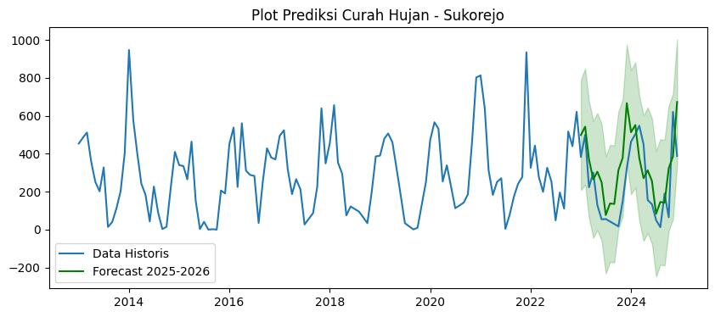

**Insight :** Sama seperti kota lain, pola musiman tetap ada, namun intensitas hujan berkurang. Puncak curah hujan lebih rendah dari historis (tidak sampai 800 mm).

1. **Tabel Data Aktual dan Hasil Prediksi**

**Keterangan :**

Data Aktual

Data Prediksi

|  |  |  |  |  |  |  |  |
| --- | --- | --- | --- | --- | --- | --- | --- |
| **Bulan dan Jumlah** | **Kendal** | **Weleri** | **Kaliwungu** | **Boja** | **Sukorejo** | **Rata-rata** | **Tahun** |
| Januari | 621 | 568 | 487 | 526 | 454 | 531 | 2013 |
| Februari | 254 | 357 | 172 | 428 | 486 | 339 | 2013 |
| Maret | 100 | 106 | 50 | 633 | 512 | 280 | 2013 |
| April | 138 | 109 | 142 | 663 | 358 | 282 | 2013 |
| Mei | 85 | 163 | 84 | 208 | 252 | 158 | 2013 |
| Juni | 247 | 246 | 247 | 465 | 202 | 281 | 2013 |
| Juli | 71 | 127 | 121 | 160 | 328 | 161 | 2013 |
| Agustus | 14 | 30 | 55 | 65 | 14 | 33 | 2013 |
| September | 40 | 19 | 0 | 53 | 40 | 22 | 2013 |
| Oktober | 95 | 28 | 88 | 214 | 110 | 107 | 2013 |
| November | 181 | 138 | 105 | 312 | 202 | 188 | 2013 |
| Desember | 301 | 294 | 230 | 377 | 406 | 322 | 2013 |
| **Total** | **2107** | **2185** | **1781** | **4104** | **3350** | **225** | **2013** |
| Januari | 1109 | 824 | 864 | 646 | 947 | 878 | 2014 |
| Februari | 354 | 509 | 344 | 323 | 578 | 422 | 2014 |
| Maret | 149 | 99 | 118 | 409 | 409 | 237 | 2014 |
| April | 62 | 41 | 32 | 448 | 241 | 165 | 2014 |
| Mei | 95 | 149 | 64 | 107 | 184 | 120 | 2014 |
| Juni | 145 | 102 | 136 | 214 | 43 | 128 | 2014 |
| Juli | 55 | 274 | 144 | 205 | 227 | 181 | 2014 |
| Agustus | 89 | 56 | 24 | 97 | 89 | 53 | 2014 |
| September | 3 | 0 | 45 | 0 | 3 | 10 | 2014 |
| Oktober | 39 | 19 | 51 | 82 | 15 | 41 | 2014 |
| November | 191 | 99 | 93 | 314 | 223 | 184 | 2014 |
| Desember | 182 | 200 | 145 | 289 | 410 | 245 | 2014 |
| **Total** | **2381** | **2372** | **2060** | **3134** | **3369** | **222** | **2014** |
| Januari | 429 | 463 | 232 | 505 | 340 | 394.0 | 2015 |
| Februari | 232 | 317 | 176 | 580 | 335 | 328.0 | 2015 |
| Maret | 192 | 177 | 196 | 379 | 265 | 242.0 | 2015 |
| April | 187 | 115 | 94 | 383 | 464 | 249.0 | 2015 |
| Mei | 100 | 74 | 77 | 183 | 153 | 117.0 | 2015 |
| Juni | 68 | 27 | 55 | 5 | 3 | 32.0 | 2015 |
| Juli | 41 | 3 | 31 | 3 | 41 | 15.0 | 2015 |
| Agustus | 0 | 18 | 0 | 18 | 0 | 4.0 | 2015 |
| September | 2 | 0 | 0 | 0 | 2 | 0.4 | 2015 |
| Oktober | 0 | 25 | 8 | 25 | 0 | 7.0 | 2015 |
| November | 121 | 191 | 85 | 201 | 206 | 161.0 | 2015 |
| Desember | 236 | 182 | 252 | 300 | 191 | 232.0 | 2015 |
| **Total** | **1606** | **1564** | **1206** | **2564** | **1959** | **148.0** | **2015** |
| Januari | 183 | 234 | 217 | 296 | 451 | 276 | 2016 |
| Februari | 343 | 312 | 215 | 599 | 538 | 401 | 2016 |
| Maret | 153 | 103 | 87 | 397 | 225 | 193 | 2016 |
| April | 239 | 134 | 177 | 384 | 561 | 299 | 2016 |
| Mei | 171 | 240 | 202 | 321 | 311 | 249 | 2016 |
| Juni | 266 | 228 | 192 | 326 | 288 | 260 | 2016 |
| Juli | 177 | 324 | 210 | 322 | 283 | 263 | 2016 |
| Agustus | 78 | 122 | 93 | 123 | 35 | 90 | 2016 |
| September | 387 | 264 | 278 | 410 | 257 | 319 | 2016 |
| Oktober | 230 | 147 | 160 | 315 | 429 | 256 | 2016 |
| November | 231 | 327 | 223 | 356 | 380 | 303 | 2016 |
| Desember | 188 | 184 | 172 | 510 | 370 | 285 | 2016 |
| **Total** | **2646** | **2619** | **2226** | **4359** | **4128** | **266** | **2016** |
| Januari | 289 | 334 | 308 | 447 | 494 | 374 | 2017 |
| Februari | 391 | 399 | 398 | 350 | 524 | 412 | 2017 |
| Maret | 168 | 98 | 120 | 474 | 317 | 235 | 2017 |
| April | 91 | 55 | 90 | 490 | 187 | 183 | 2017 |
| Mei | 29 | 139 | 44 | 294 | 266 | 154 | 2017 |
| Juni | 158 | 136 | 172 | 225 | 212 | 181 | 2017 |
| Juli | 65 | 103 | 66 | 57 | 27 | 64 | 2017 |
| Agustus | 5 | - | - | - | - | 1 | 2017 |
| September | 21 | 45 | 39 | 64 | 87 | 51 | 2017 |
| Oktober | 177 | 111 | 316 | 336 | 225 | 233 | 2017 |
| November | 257 | 161 | 297 | 736 | 640 | 418 | 2017 |
| Desember | 242 | 350 | 162 | 413 | 349 | 303 | 2017 |
| **Total** | **1893** | **1931** | **2012** | **3886** | **3328** | **217** | **2017** |
| Januari | 296 | 254 | 288 | 474 | 457 | 354 | 2018 |
| Februari | 604 | 472 | 631 | 726 | 656 | 618 | 2018 |
| Maret | 160 | 213 | 175 | 340 | 354 | 248 | 2018 |
| April | 106 | 230 | 162 | 233 | 294 | 205 | 2018 |
| Mei | 59 | 70 | 40 | 114 | 75 | 72 | 2018 |
| Juni | 34 | 20 | 59 | 110 | 122 | 69 | 2018 |
| Juli | - | - | - | - | - | - | 2018 |
| Agustus | - | - | - | - | 95 | 19 | 2018 |
| September | - | - | - | 70 | - | 14 | 2018 |
| Oktober | 7 | 22 | 12 | - | 34 | 19 | 2018 |
| November | 62 | 115 | 104 | 339 | 195 | 163 | 2018 |
| Desember | 146 | 251 | 160 | 450 | 386 | 279 | 2018 |
| **Total** | **1474** | **1647** | **1631** | **2856** | **2668** | **187** | **2018** |
| Januari | 265 | 414 | 359 | 438 | 390 | 373 | 2019 |
| Februari | 214 | 228 | 203 | 475 | 479 | 320 | 2019 |
| Maret | 233 | 240 | 181 | 524 | 507 | 337 | 2019 |
| April | 235 | 166 | 239 | 574 | 461 | 335 | 2019 |
| Mei | 82 | 161 | 149 | 294 | 324 | 202 | 2019 |
| Juni | - | - | - | - | - | - | 2019 |
| Juli | 5 | 37 | 7 | 4 | 34 | 17 | 2019 |
| Agustus | - | - | 3 | 25 | - | 6 | 2019 |
| September | - | 4 | - | 5 | 1 | 2 | 2019 |
| Oktober | - | - | 19 | 4 | 10 | 7 | 2019 |
| November | 10 | 15 | 50 | 157 | 133 | 73 | 2019 |
| Desember | 143 | 144 | 252 | 295 | 251 | 217 | 2019 |
| **Total** | **1187** | **1409** | **1462** | **2795** | **2590** | **172** | **2019** |
| Januari | 345 | 539 | 375 | 360 | 473 | 418 | 2020 |
| Februari | 353 | 330 | 260 | 606 | 566 | 423 | 2020 |
| Maret | 256 | 258 | 210 | 474 | 532 | 346 | 2020 |
| April | 149 | 93 | 183 | 513 | 254 | 238 | 2020 |
| Mei | 233 | 178 | 243 | 330 | 339 | 265 | 2020 |
| Juni | - | - | - | - | - | - | 2020 |
| Juli | 80 | 121 | 59 | 77 | 113 | 90 | 2020 |
| Agustus | 53 | 38 | 44 | 46 | 127 | 62 | 2020 |
| September | 135 | 50 | 100 | 100 | 143 | 106 | 2020 |
| Oktober | 134 | 65 | 122 | 460 | 186 | 193 | 2020 |
| November | 206 | 282 | 185 | 543 | 469 | 337 | 2020 |
| Desember | 337 | 155 | 298 | 499 | 802 | 418 | 2020 |
| **Total** | **2281** | **2109** | **2079** | **4008** | **4004** | **263** | **2020** |
| Januari | 209 | 384 | 290 | 943 | 813 | 528 | 2021 |
| Februari | 514 | 715 | 727 | 449 | 639 | 609 | 2021 |
| Maret | 151 | 242 | 153 | 363 | 312 | 244 | 2021 |
| April | 65 | 105 | 60 | 171 | 183 | 117 | 2021 |
| Mei | 174 | 111 | 253 | 312 | 251 | 220 | 2021 |
| Juni | 100 | 95 | 237 | 511 | 271 | 243 | 2021 |
| Juli | 18 | 5 | 22 | 23 | 4 | 14 | 2021 |
| Agustus | 13 | 38 | 19 | 190 | 78 | 68 | 2021 |
| September | 92 | 215 | 64 | 205 | 174 | 150 | 2021 |
| Oktober | 28 | 15 | 16 | 121 | 241 | 84 | 2021 |
| November | 279 | 325 | 217 | 462 | 278 | 312 | 2021 |
| Desember | 93 | 167 | 71 | 515 | 935 | 356 | 2021 |
| **Total** | **1736** | **2417** | **2129** | **4265** | **4179** | **245** | **2021** |
| Januari | 186 | 260 | 267 | 278 | 326 | 263 | 2022 |
| Februari | 298 | 323 | 204 | 494 | 443 | 352 | 2022 |
| Maret | 79 | 192 | 101 | 209 | 278 | 172 | 2022 |
| April | 138 | 188 | 101 | 183 | 199 | 162 | 2022 |
| Mei | 120 | 271 | 116 | 342 | 326 | 235 | 2022 |
| Juni | 150 | 147 | 114 | 216 | 253 | 176 | 2022 |
| Juli | 36 | 88 | 48 | 90 | 49 | 62 | 2022 |
| Agustus | 11 | 30 | 20 | 38 | 196 | 59 | 2022 |
| September | 169 | 178 | 135 | 298 | 111 | 178 | 2022 |
| Oktober | 164 | 393 | 141 | 551 | 517 | 353 | 2022 |
| November | 228 | 185 | 247 | 419 | 440 | 304 | 2022 |
| Desember | 323 | 368 | 205 | 449 | 621 | 393 | 2022 |
| **Total** | **1902** | **2623** | **1699** | **3567** | **3759** | **226** | **2022** |
| Januari | 254 | 217 | 284 | 510 | 383 | 330 | 2023 |
| Februari | 275 | 333 | 377 | 327 | 500 | 362 | 2023 |
| Maret | 191 | 201 | 135 | 320 | 223 | 214 | 2023 |
| April | 58 | 77 | 69 | 383 | 301 | 178 | 2023 |
| Mei | 132 | 65 | 80 | 192 | 129 | 120 | 2023 |
| Juni | 73 | 32 | 38 | 23 | 54 | 44 | 2023 |
| Juli | - | 6 | 10 | 55 | 56 | 25 | 2023 |
| Agustus | - | - | - | - | - | - | 2023 |
| September | - | - | - | - | - | - | 2023 |
| Oktober | 35 | 10 | 38 | 23 | 17 | 25 | 2023 |
| November | 124 | 16 | 207 | 265 | 149 | 152 | 2023 |
| Desember | 98 | 125 | 249 | 524 | 322 | 264 | 2023 |
| **Total** | **1240** | **1082** | **1487** | **2622** | **2134** | **143** | **2023** |
| Januari | 241 | 139 | 133 | 336 | 464 | 263 | 2024 |
| Februari | 87 | 185 | 82 | 532 | 503 | 278 | 2024 |
| Maret | 314 | 366 | 183 | 455 | 548 | 373 | 2024 |
| April | 313 | 214 | 188 | 327 | 449 | 298 | 2024 |
| Mei | 27 | 50 | 35 | 200 | 156 | 94 | 2024 |
| Juni | 102 | 56 | 42 | 104 | 134 | 88 | 2024 |
| Juli | 32 | 33 | 4 | 35 | 50 | 31 | 2024 |
| Agustus | 28 | 3 | 8 | 42 | 13 | 19 | 2024 |
| September | 27 | 74 | 30 | 178 | 190 | 100 | 2024 |
| Oktober | 18 | - | 32 | 60 | 65 | 35 | 2024 |
| November | 205 | 241 | 116 | 477 | 621 | 332 | 2024 |
| Desember | 286 | 331 | 129 | 287 | 388 | 284 | 2024 |
| **Total** | **1680** | **1692** | **982** | **3033** | **3581** | **183** | **2024** |
| Januari | 240 | 373 | 371 | 521 | 498 | 401 | 2025 |
| Februari | 265 | 347 | 355 | 469 | 542 | 396 | 2025 |
| Maret | 161 | 166 | 164 | 425 | 370 | 257 | 2025 |
| April | 171 | 113 | 152 | 384 | 265 | 217 | 2025 |
| Mei | 150 | 130 | 150 | 253 | 305 | 198 | 2025 |
| Juni | 151 | 97 | 165 | 235 | 249 | 179 | 2025 |
| Juli | 94 | 75 | 96 | 102 | 76 | 89 | 2025 |
| Agustus | 74 | 32 | 56 | 72 | 137 | 74 | 2025 |
| September | 132 | 69 | 96 | 121 | 135 | 111 | 2025 |
| Oktober | 123 | 77 | 118 | 229 | 313 | 172 | 2025 |
| November | 141 | 140 | 186 | 378 | 378 | 245 | 2025 |
| Desember | 177 | 170 | 215 | 404 | 666 | 326 | 2025 |
| **Total** | **1879** | **1789** | **2124** | **3593** | **3934** | **222** | **2025** |
| Januari | 137 | 289 | 376 | 248 | 513 | 313 | 2026 |
| Februari | 142 | 289 | 362 | 289 | 551 | 327 | 2026 |
| Maret | 96 | 134 | 167 | 411 | 376 | 237 | 2026 |
| April | 97 | 93 | 154 | 390 | 271 | 201 | 2026 |
| Mei | 85 | 114 | 152 | 248 | 312 | 182 | 2026 |
| Juni | 82 | 86 | 167 | 237 | 256 | 166 | 2026 |
| Juli | 57 | 68 | 98 | 100 | 83 | 81 | 2026 |
| Agustus | 47 | 29 | 58 | 72 | 145 | 70 | 2026 |
| September | 68 | 64 | 94 | 120 | 141 | 97 | 2026 |
| Oktober | 63 | 71 | 117 | 229 | 323 | 161 | 2026 |
| November | 68 | 131 | 184 | 377 | 386 | 229 | 2026 |
| Desember | 81 | 160 | 216 | 403 | 673 | 307 | 2026 |
| **Total** | **1023** | **1528** | **2145** | **3124** | **4030** | **198** | **2026** |

1. **Tabel Evaluasi**
2. **Kota Kendal**

|  |  |
| --- | --- |
| **Metrik Evaluasi** | **Nilai** |
| Mean Absolute Error (MAE) | 72.10 |
| Root Mean Square Eror (RMSE) | 95.93 |
| Mean Absolute Percentage Eror (MAPE) | 89.41 |

1. **Kota Weleri**

|  |  |
| --- | --- |
| **Metrik Evaluasi** | **Nilai** |
| Mean Absolute Error (MAE) | 79.35 |
| Root Mean Square Eror (RMSE) | 96.65 |
| Mean Absolute Percentage Eror (MAPE) | 239.95 |

1. **Kota Kaliwungu**

|  |  |
| --- | --- |
| **Metrik Evaluasi** | **Nilai** |
| Mean Absolute Error (MAE) | 83.80 |
| Root Mean Square Eror (RMSE) | 104.66 |
| Mean Absolute Percentage Eror (MAPE) | 288.49 |

1. **Kota Boja**

|  |  |
| --- | --- |
| **Metrik Evaluasi** | **Nilai** |
| Mean Absolute Error (MAE) | 89.86 |
| Root Mean Square Eror (RMSE) | 106.47 |
| Mean Absolute Percentage Eror (MAPE) | 136.66 |

1. **Kota Sukorejo**

|  |  |
| --- | --- |
| **Metrik Evaluasi** | **Nilai** |
| Mean Absolute Error (MAE) | 146.83 |
| Root Mean Square Eror (RMSE) | 172.81 |
| Mean Absolute Percentage Eror (MAPE) | 213.82 |